You are cordially invited to attend a mathematics education research
presentation by

Dr. Edward A. Silver
William A. Brownell Collegiate Professor in Education
Professor of Education and Mathematics, University of Michigan, Ann Arbor
Dean, School of Education, University of Michigan-Dearborn

Supporting High-Quality Mathematics Teaching:
(How) Can We Scale Up to Version 2.0?

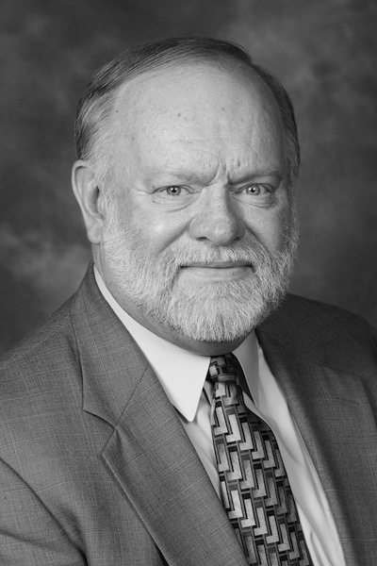 | High quality mathematics instruction has a significant effect on  students' school achievement and their access to careers in STEM-related fields. Yet most children in this country do not have sustained access to such teaching. Supporting mathematics teachers to provide high quality instruction is a problem of massive scale. Although many teacher professional development initiatives have indicated promise and possibility, the impact of these initiatives has been limited in scope and scale. Large-scale improvement has remained an elusive dream. This presentation will analyze whether and how it might be possible to build systematically on a foundation of prior work to improve mathematics teaching practice in the U.S. on a large scale. The session will also consider some of the central challenges  entailed by this agenda.
Tuesday, November 6, 2012
3:30 – 5:00 p.m.
252 Erickson Hall

A reception will immediately follow the presentation.

Dr. Silver is a candidate for the
Lappan-Phillips-Fitzgerald Endowed Chair in Mathematics Education

Edward A. Silver’s scholarly interests include the study of mathematical thinking, especially mathematical problem solving and problem posing; the design and analysis of intellectually engaging and equitable mathema- tics instruction for students; innovative methods of assessing and reporting mathematics achievement; and effective models for enhancing the knowledge of teachers of mathematics. He has published numerous articles, chapters, and books on these topics. He served as editor of the Journal for Research in Mathematics Education from 2000-2004, and as co-editor of The Elementary School Journal from 2008-2010. He was the 2004 recipient of the Award for Outstanding Contributions of Educational Research to Practice from the American Educational Research Association, the 2007 recipient of the Iris Carl Memorial Leadership and Equity Award from TODOS, the 2009 recipient of the Lifetime Achievement Award from the National Council of Teachers of Mathematics, and the 2011 recipient of the Senior Scholar Award from the American Educational Research Association Special Interest Group for Research in Mathematics Education (SIG/RME).

