You are cordially invited to attend the
MSU Mathematics Education Colloquium

Wednesday, September 12, 2012
3:30 – 5 p.m.
252 Erickson Hall - Michigan State University

Gail Burrill
Program in Mathematics Education
Michigan State University

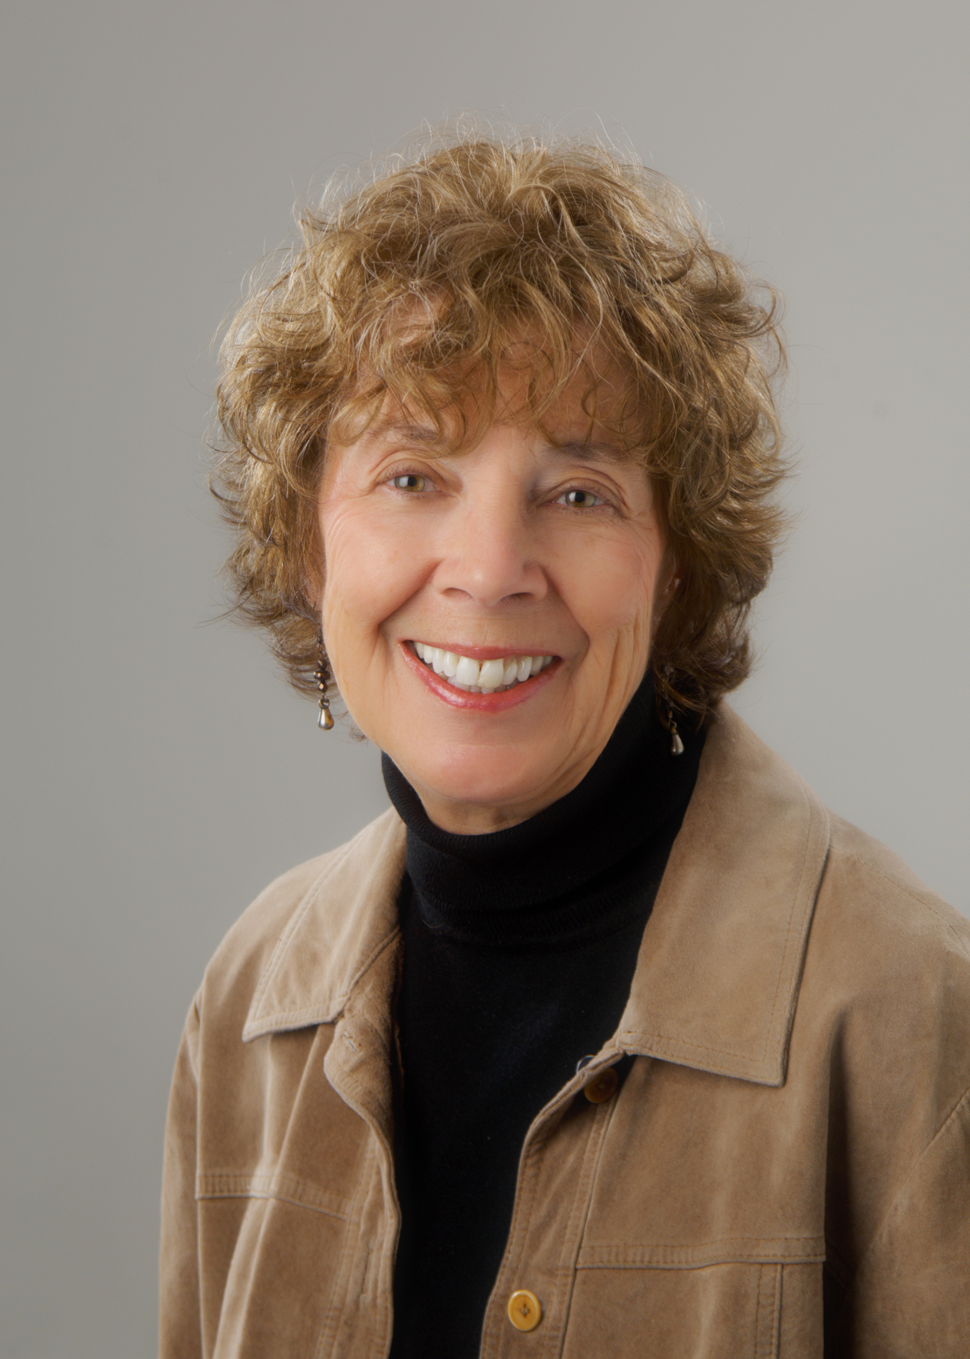

Why aren’t we paying attention to the research on teaching and learning algebra?

Over the years, research about teaching and learning algebra has provided findings and offered suggestions that typically have not been incorporated into the design of curricula nor used in helping teachers shape instruction in their algebra classes. Today “algebra for all” is central in the Common Core State Standards, yet for many students, even those who excel, algebra is a set of procedures and algorithms, which they struggle, often unsuccessfully, to master. What can be learned from both research and experience about how core algebraic concepts are presented to students? What do we know about instruction that can increase student access to these concepts? What can we, as a mathematics education community, do to make better links between research and practice?

The session will also highlight issues related to teaching and learning algebra that will be addressed by speakers in the 2012-13 MSU mathematics education colloquia and allow us to frame questions to help us think about how to move forward in more productive ways than we have in the past.

Gail Burrill was a secondary teacher and department chair in suburban Milwaukee, Wisconsin for over 28 years. She is currently a Mathematics Specialist in the Program for Mathematics Education at Michigan State University. She served as President of the National Council of Teachers of Mathematics (NCTM) and as Director of the Mathematical Sciences Education Board. She co-directs the Institute for Advanced Study’s International Seminar and the Secondary School Teachers Program component of the Park City Mathematics Institute. Burrill is an instructor for Teachers Teaching with Technology and a senior mathematics advisor to Texas Instruments Education Technology. She received a Presidential Award for Excellence in Teaching Mathematics, an honorary doctorate from Rose Holman Institute of Technology, and the NCTM Lifetime Achievement Award. Her research interests are statistics education, the use of technology in teaching secondary mathematics, and issues related to what it means to teach mathematics. The author of numerous books and articles on statistics and mathematics education, she has spoken nationally and internationally on issues in teaching and learning mathematics.

The Program in Mathematics Education sponsors this event.

